TERRAFORM TASK -02
1.) Execute all the templates shown in the video.
- Created a main.tf file.
Added two Terraform resources:
- random_pet.mypet to generate a random pet name.
- local_file.pet to create the file /root/pets.txt.
- Terraform has not been initialized yet (terraform init not run).
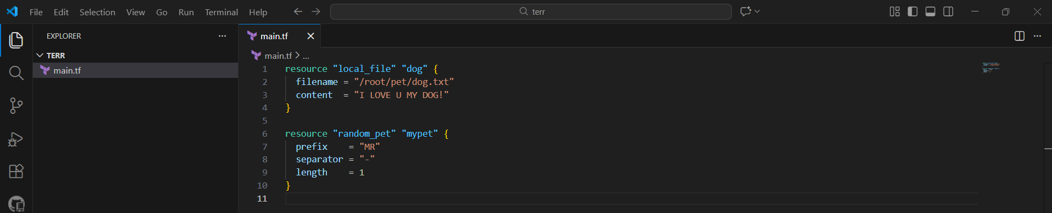
- Ran terraform init
- Providers downloaded (local, random)
- .terraform folder and .terraform.lock.hcl created
- Terraform project initialized successfully
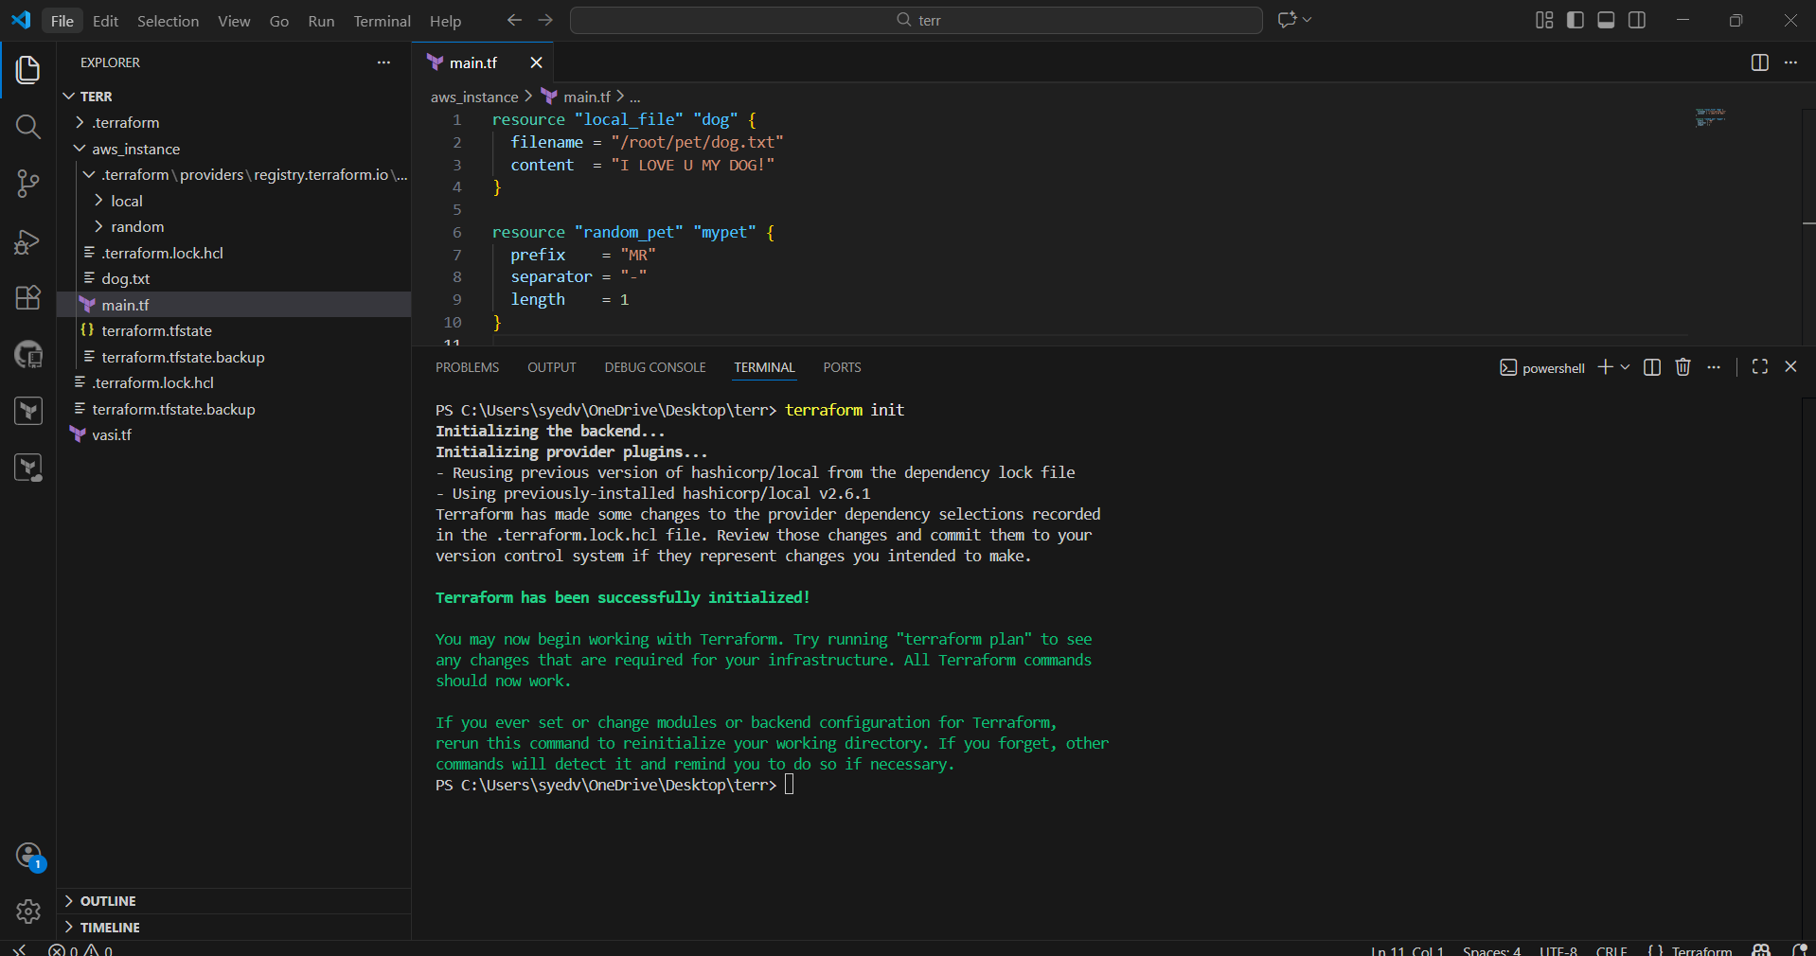
- Terraform displays the execution plan
- Both resources are created
- You type yes to apply
- pets.txt file is created
- random pet name is generated
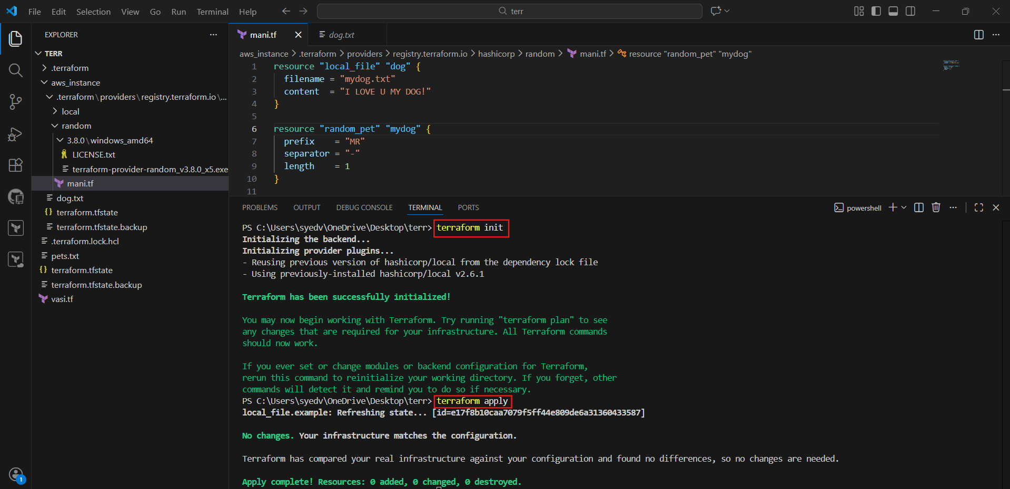
- terraform.tfstate file appears.
- State stores:
  - Resource IDs
  - File content hash
  - Provider metadata
- Terraform now tracks real infrastructure
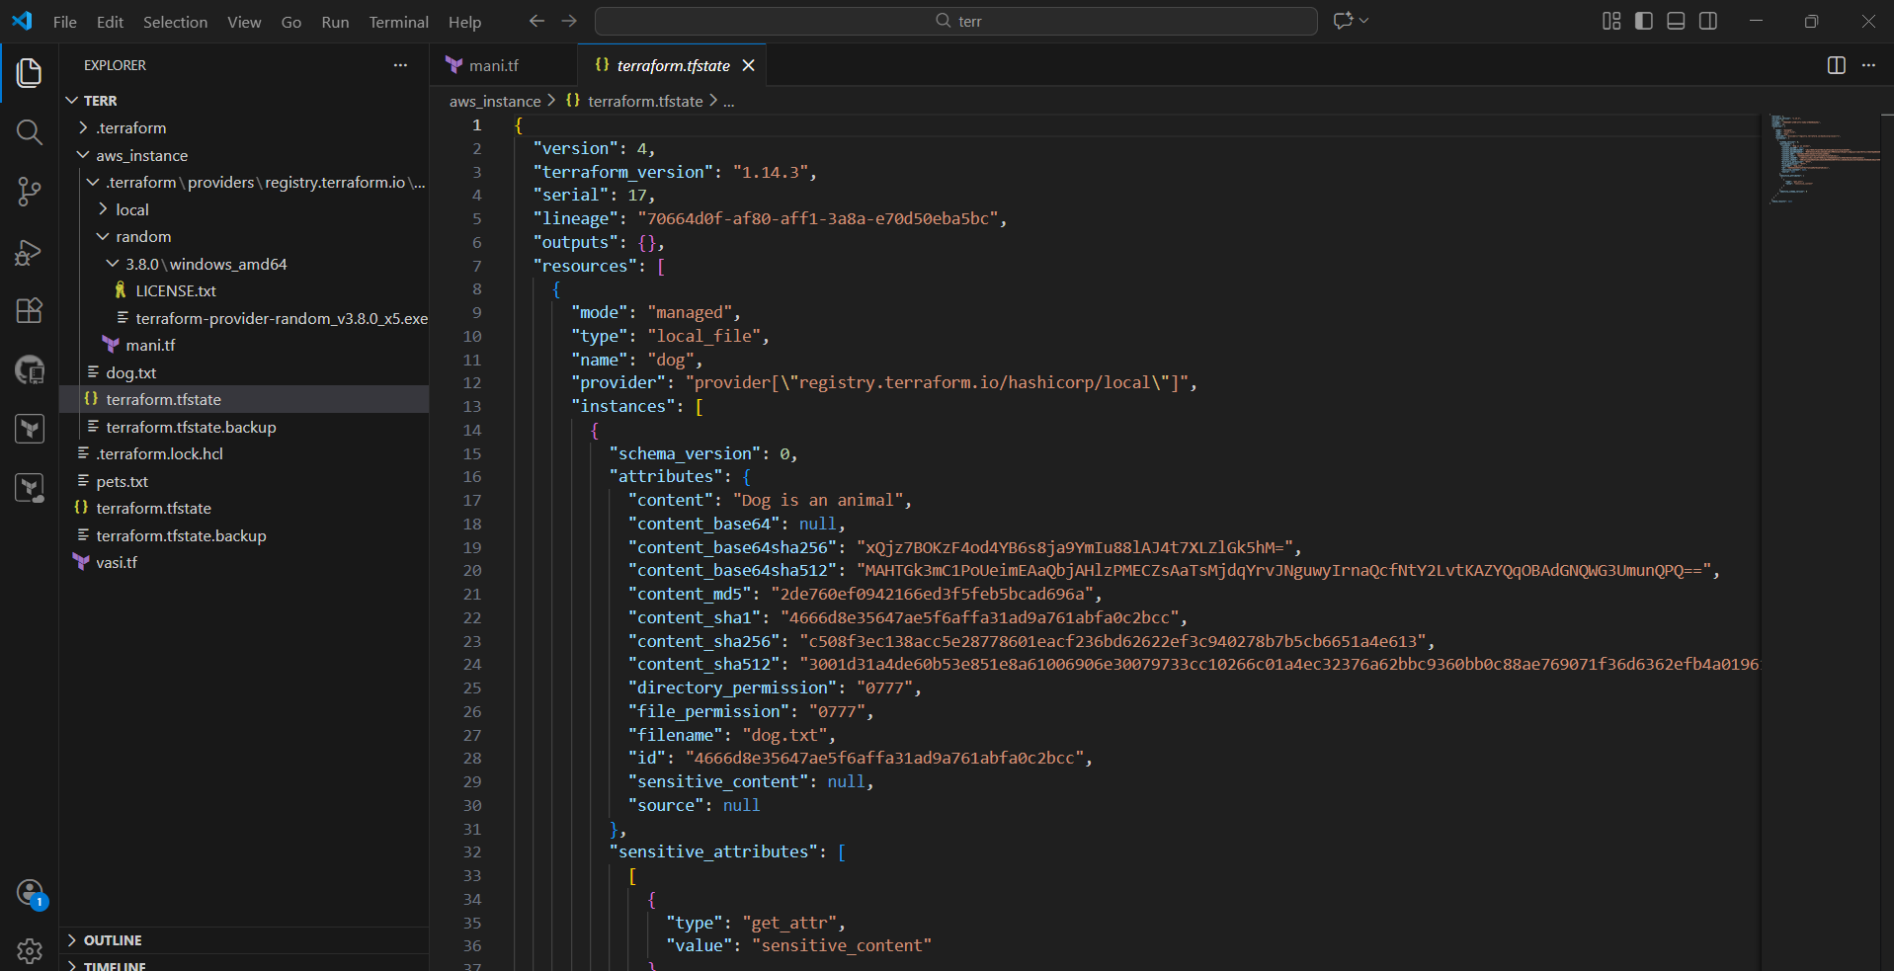
- modified content inside local_file.
- This causes a ForceNew change.
- Terraform detects drift between config and state
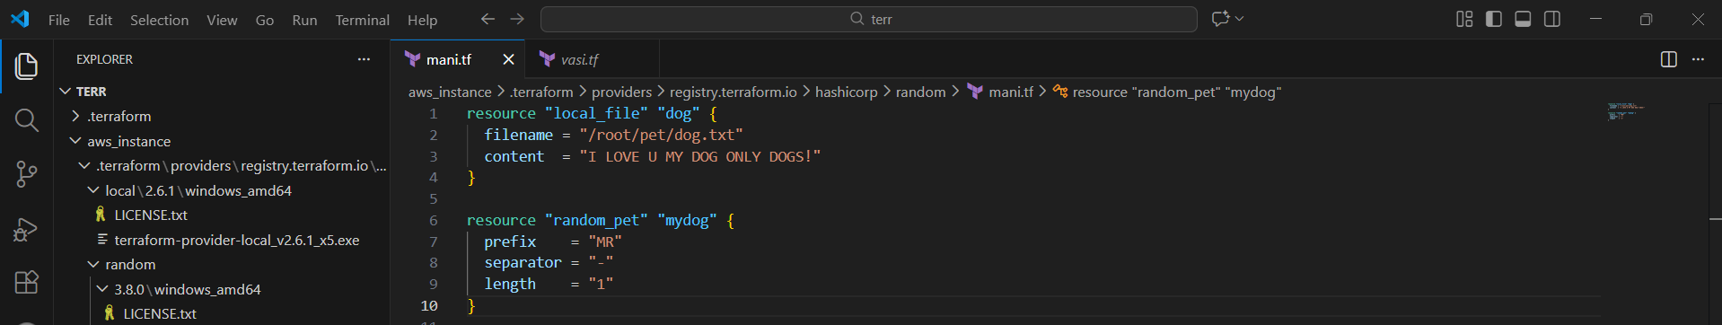
- Plan shows:
  - local_file.pet must be replaced
- Old file is destroyed.
- New file is created.
Key point
- Default behavior = destroy → create
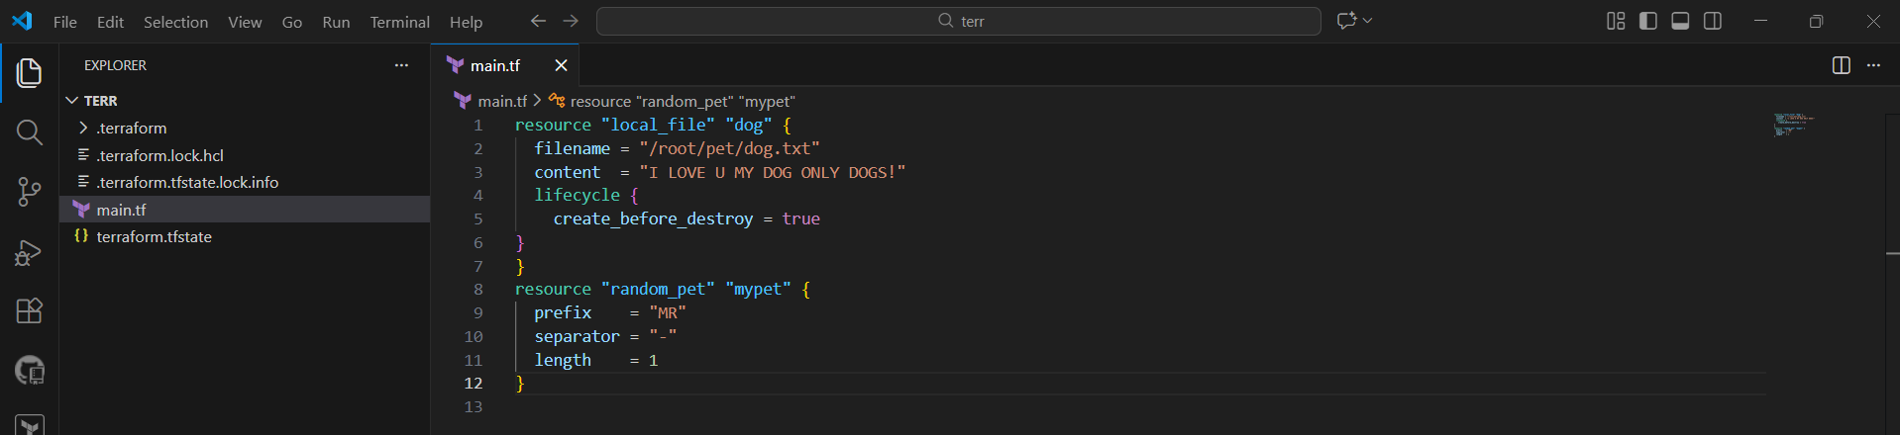
- New file is created first.
- Old file is destroyed after.
Key point
- Safe replacement strategy.
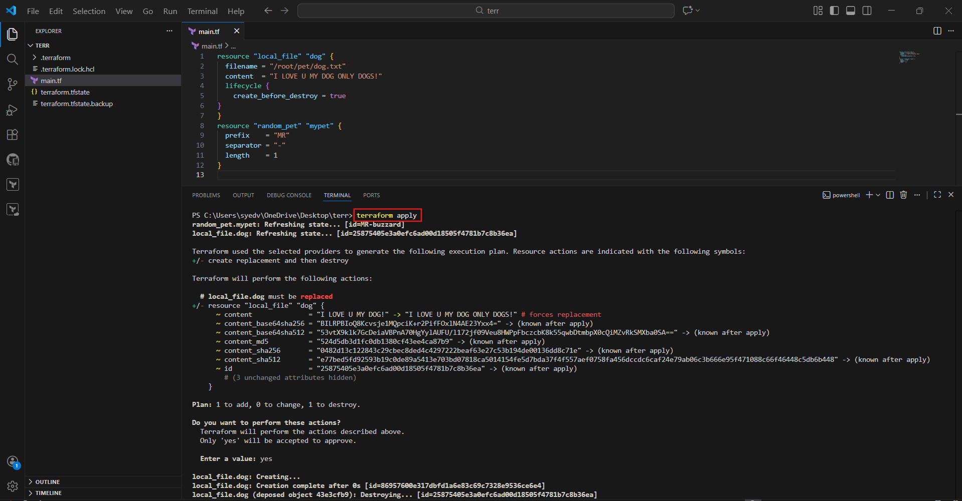
- added:
- lifecycle {
- }
Key point
Protects critical resources from deletion
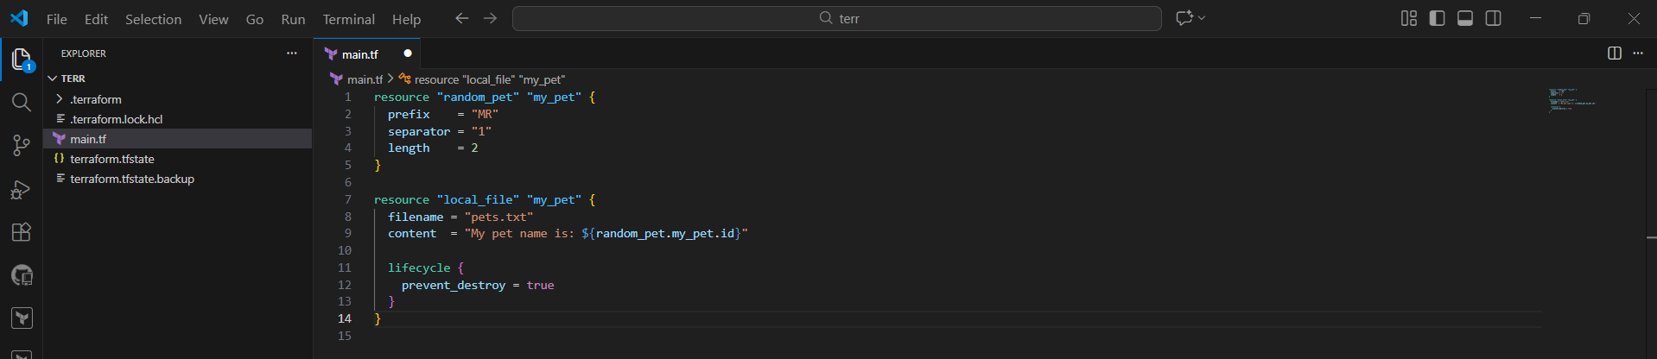
- Terraform refuses to destroy the resource.
- Apply fails if replacement is required.
Key point
- Manual intervention required to remove protection
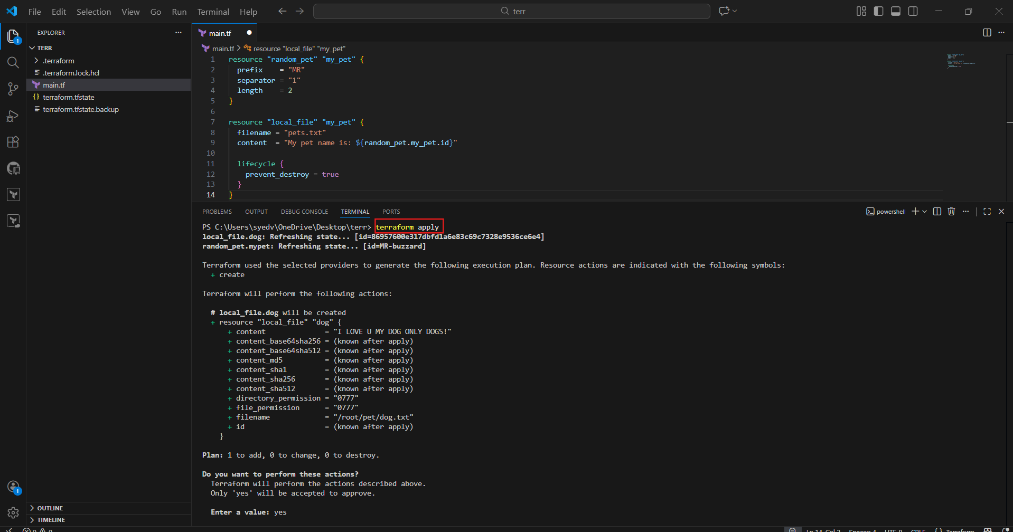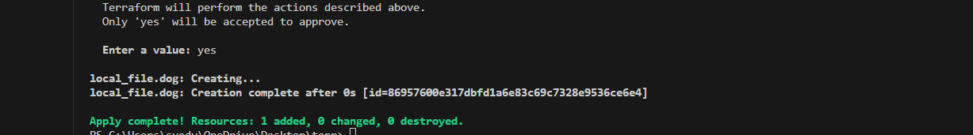
Created a new file called variables.tf
Defined reusable input variables:
- pet_filename
- pet_content
- random_pet_prefix
- random_pet_separator
- random_pet_length
Key Points
- Each variable has:
  - description
  - type
  - default
- Defaults allow Terraform to run without passing values manually.

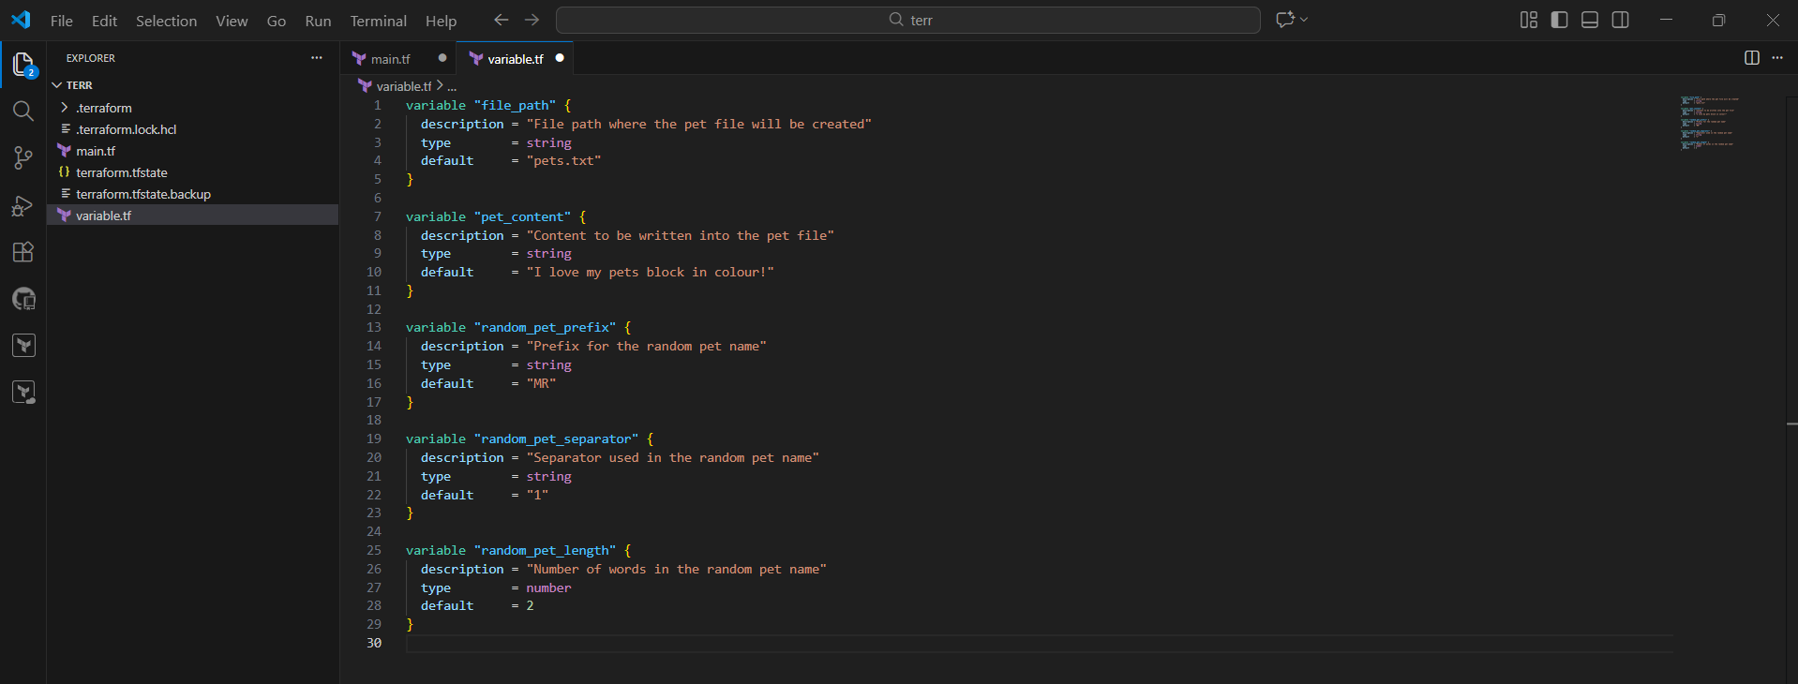
- Random Pet Creation:
  - The random_pet.my_pet resource generates a random pet name with the prefix "MR" and a single word (length = 1).
  - Example output: MR.fish.
- File Creation:
  - The local_file.my_pet resource creates a file at the path defined by var.filename.
  - Its content is set to include the random pet name: "My pet name is: MR.fish".
- Safe Lifecycle Management:
  - prevent_destroy = true ensures Terraform never deletes the file, even if you change or remove the resource in the code.
ignore_changes = [content] ensures Terraform does not replace or update the file if the content changes later
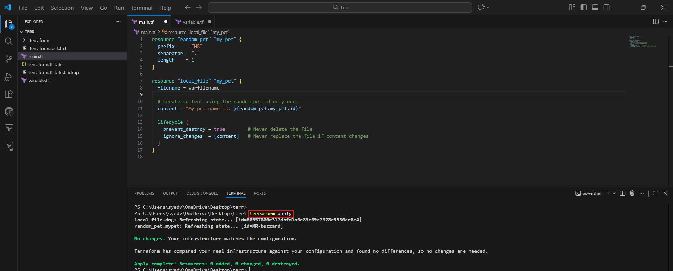

- Integrate Terraform in Jenkins using the Terraform plugin.
- opened main.tf directly in GitHub.
- local_file and random_pet resources reference variables using var.*.
Why this matters
- No hard-coded values.
- Configuration is reusable and CI/CD friendly.
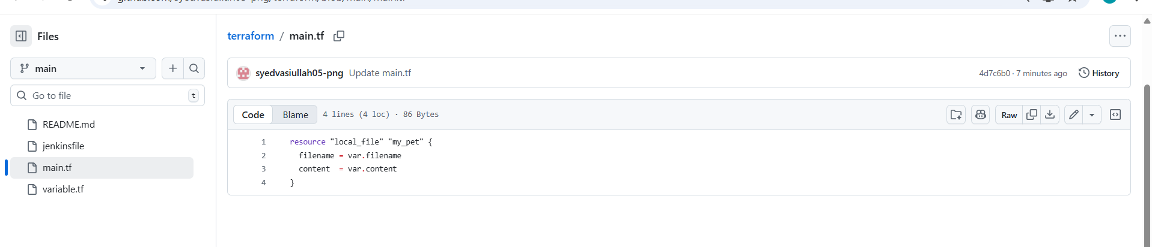
- defined all input variables:
  - pet_filename (now /tmp/pets.txt)
  - pet_content
  - random_pet_prefix
  - random_pet_separator
  - random_pet_length
Why this matters
- Fixes Jenkins permission issue.
- Ensures Terraform config is valid
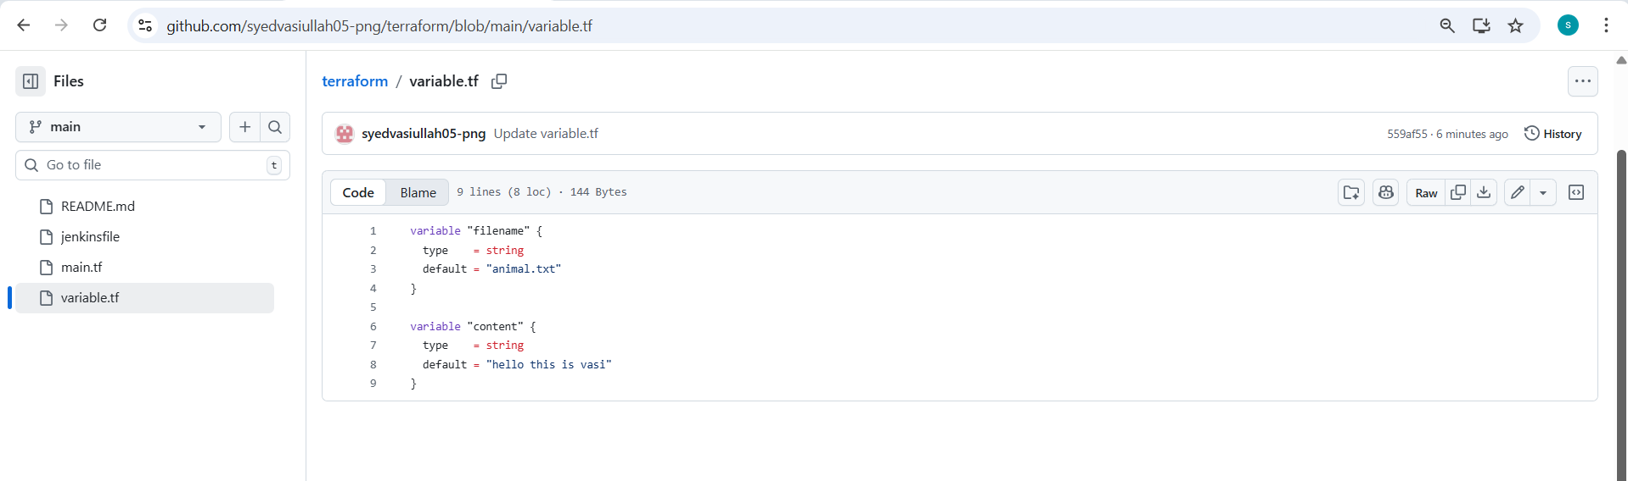
- created a file named Jenkinsfile
- Pipeline stages included:
  - Checkout
  - Terraform Init
  - Terraform Plan
  - Terraform Apply (manual approval)
Why this matters
- Jenkins reads pipeline directly from SCM.
- Follows DevOps best practice (pipeline as code)

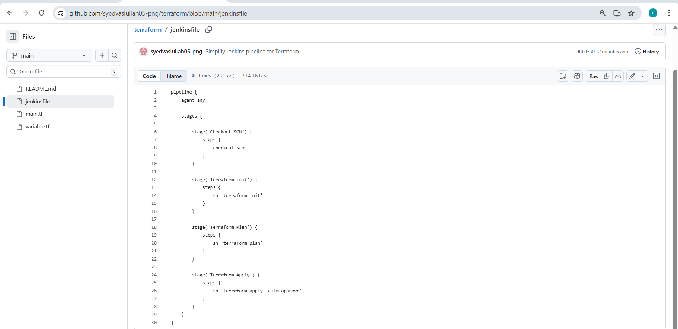
- jenkins → New Item
- Job name: terraform-pipeline-task-02
- Job type: Pipeline
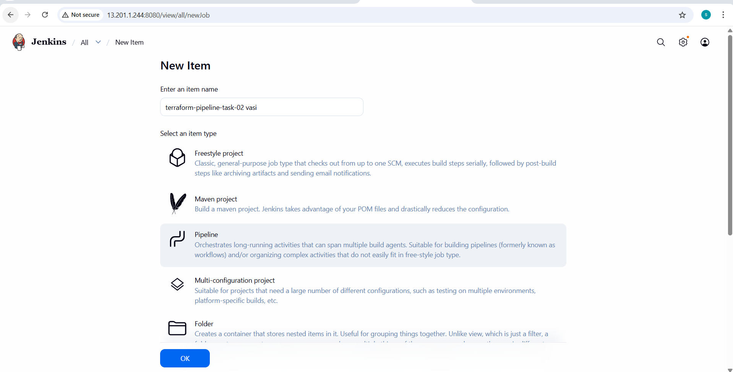
- Definition: Pipeline script from SCM
- SCM: Git
- Repository URL:
- https://github.com/mujahed1716/terraform.git
Why this matters
- Jenkins automatically fetches pipeline code from GitHub.
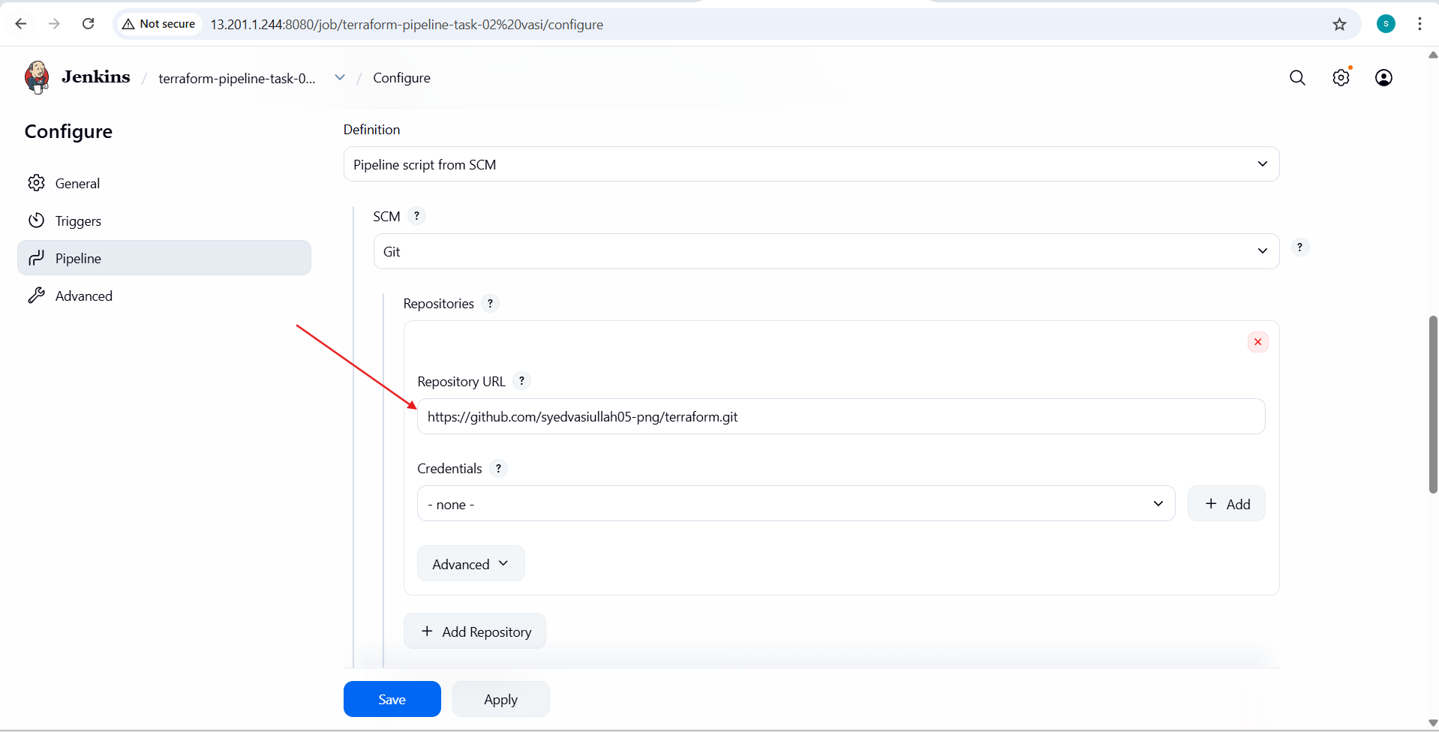
- Branch Specifier:
- */main
- Script Path:
- Jenkinsfile
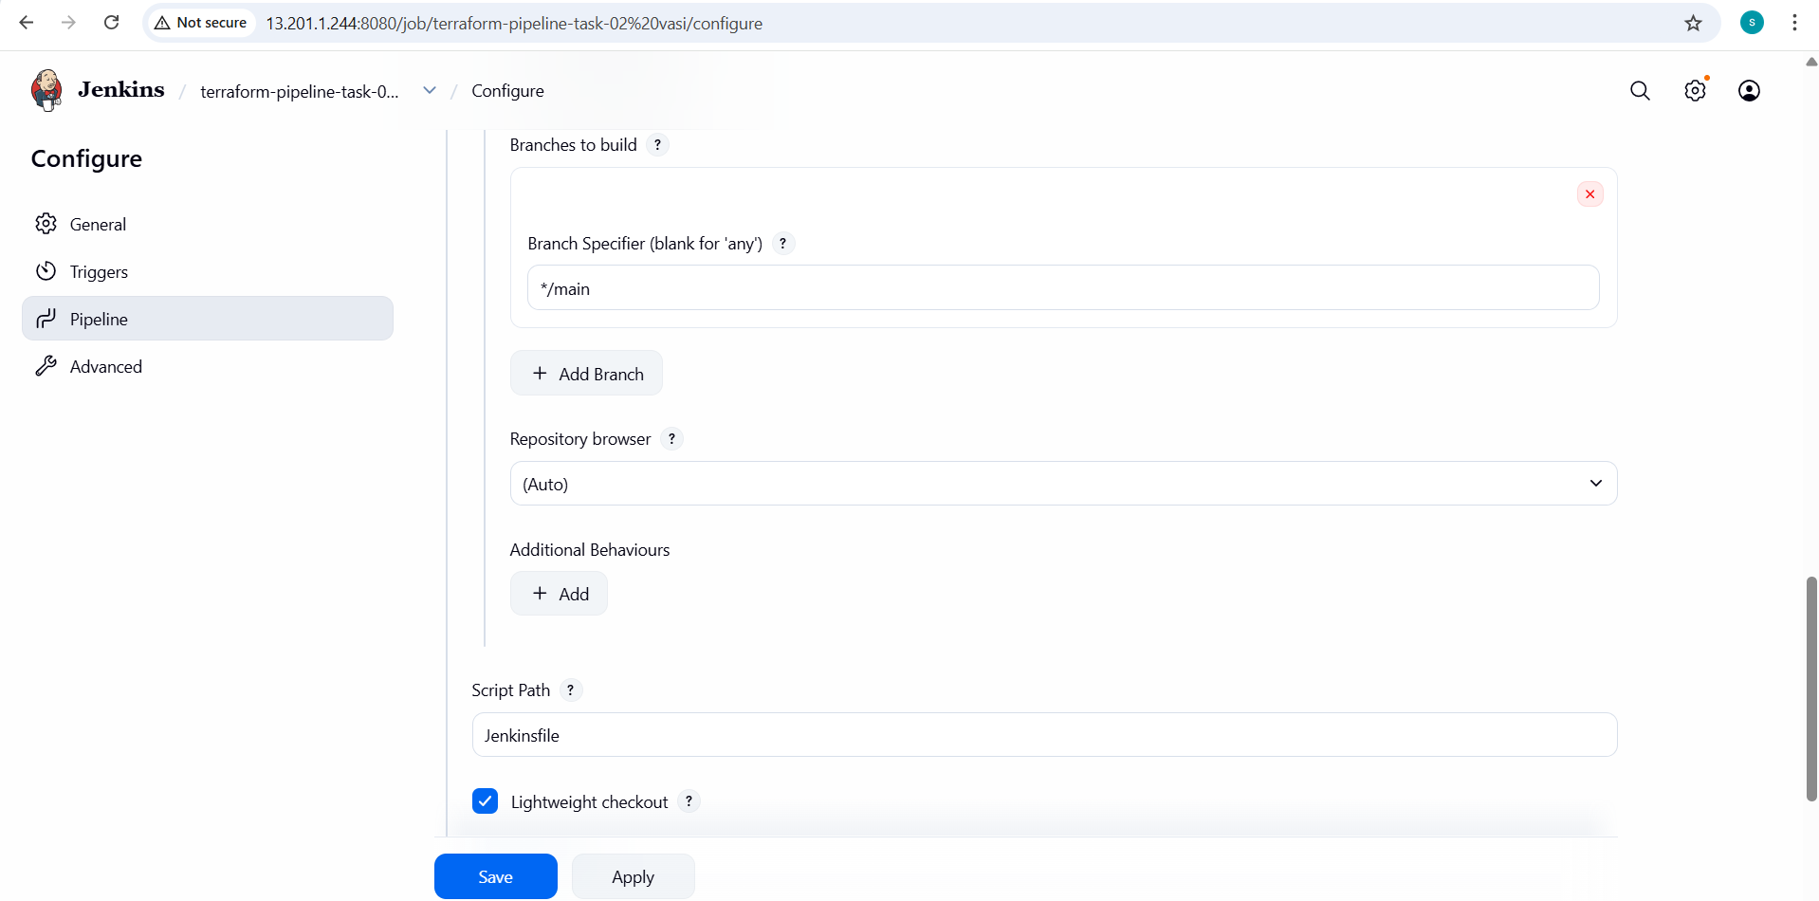
- Finally build is successfull
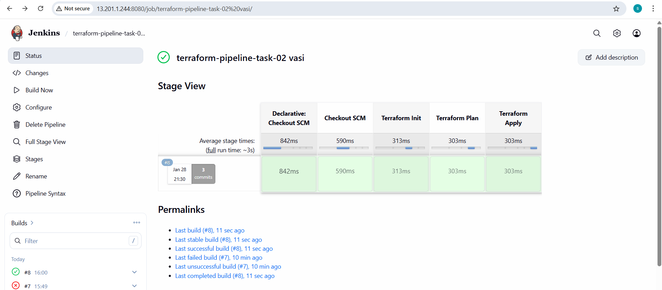
- Build is triggered manually.
- Jenkins performs:
  - Git checkout
  - terraform init
  - terraform plan
  - Manual approval
  - terraform apply
Result
- Resources created successfully.
- File written to /tmp/pets.txt.
- Random pet name generated.

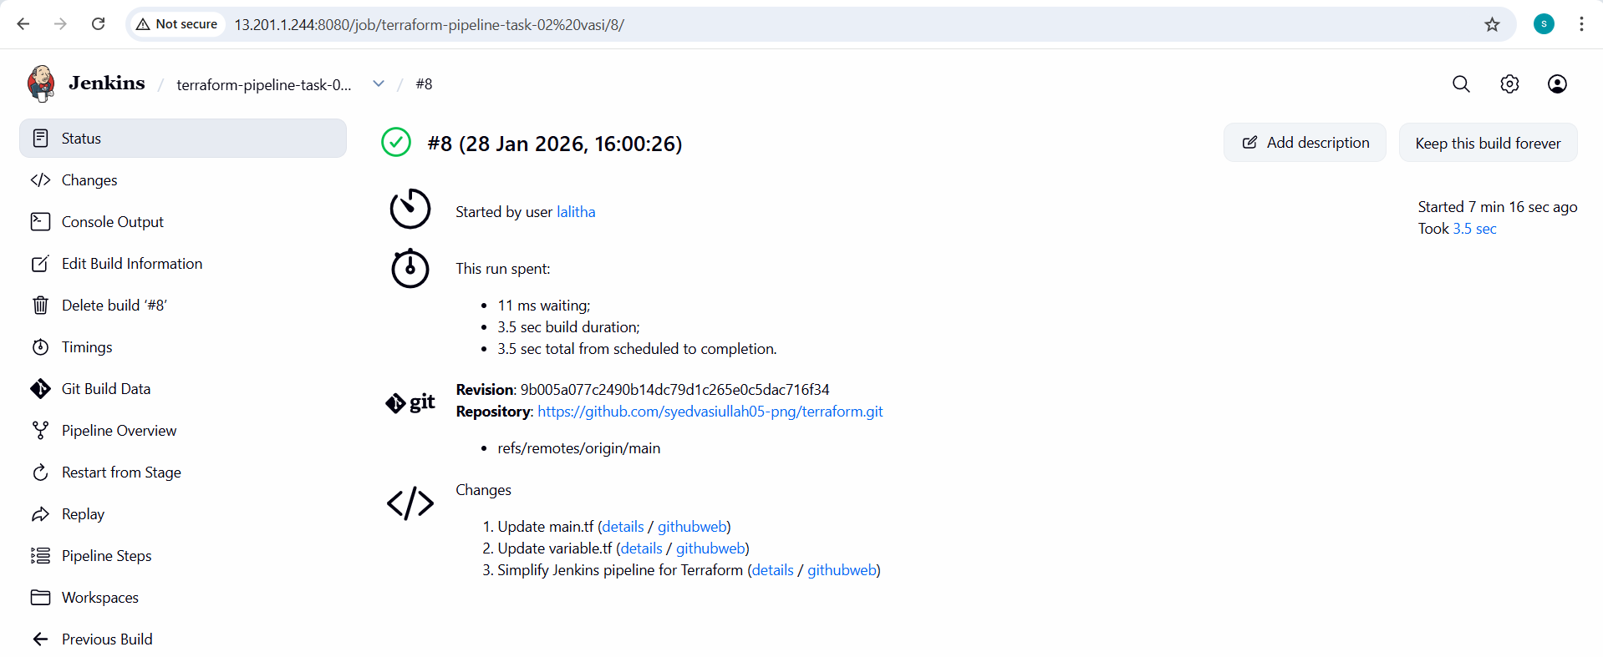
- Check the console output
